School Discipline

There are a variety of student discipline programs used in the schools of the Washington Elementary School District. When substitute teaching at a school, especially if not familiar with the school’s discipline practices, we encourage you to perform the following:

- Request school’s discipline program prior to starting the school day;
- Seek a neighbor teacher to discuss discipline practices;
- Seek a neighbor teacher’s or school administration’s assistance when necessary;
- Do not implement your discipline practices without confirming with school administration.

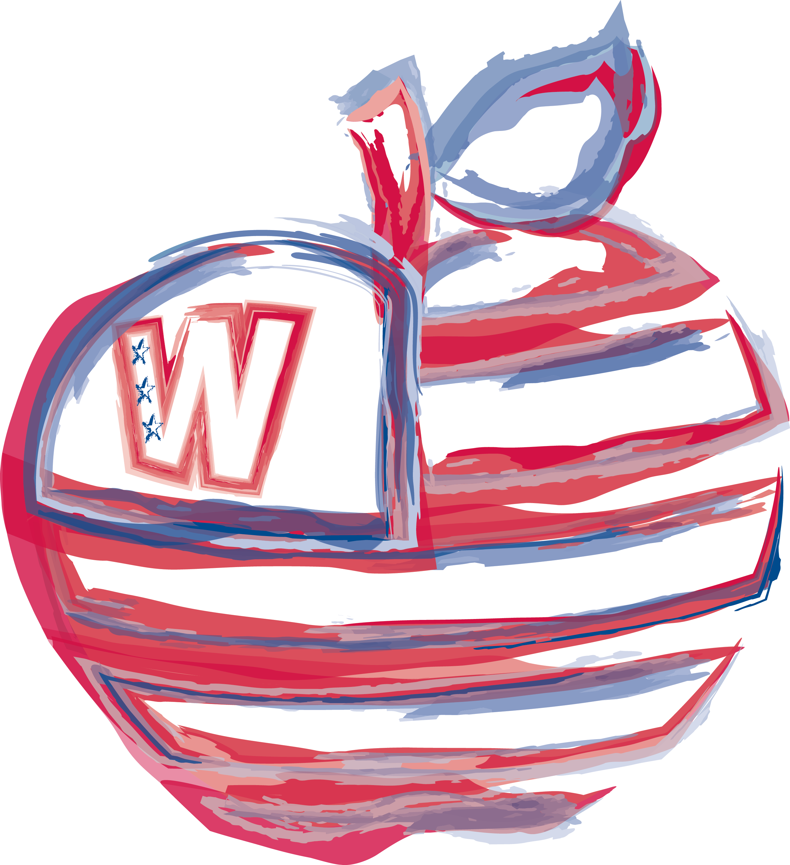

Problem Solving

The Washington Elementary School District recognizes that differences and misunderstandings will occur periodically. We encourage solving these problems appropriately. If you have a problem, it can usually be resolved by following these steps

- Any concern should first be discussed with the principal at the school.

- If the principal cannot solve the problem or if you are not satisfied after Step 1, you should ask to speak to the Human Resources Department. Please contact substitute services to be directed to appropriate staff member.

In the event you have a concern, and for personal reasons you cannot follow the above steps in this procedure, you may go directly to the Human Resources Department.

